**Question:-**



**Explanation:-**

First we need to register piggybank.jar



We have created reference named A below and we have loaded the file Pokemon.csv and we have loaded it using **CSVExcelStorage()** function. Now relation A is referring the file named **Pokemon.csv.**



Now we have generated $1 and $7 as Name and Defence for each and every row in A and is referred by relation B.



Now we are filtering relation B by defence >55.



**Question 2:-**



**Explanation:-**

Here we need to grouping relation C by all because we need to count the no of innerbags.



Here we are generating COUNT because we can get the number of players getting selected and it is referred by relation E.



Now we are **loading the result of relation E using dump** command.



Please find the output of Dump Command so that we can get the number of players taking part in competition after getting Selected.



**Question 3:-**



**Explanation:-**

Relation C refers the file that contains Pokemons that are selected in Qualifying Round. So foreach and every row in Relation C, we are generating Random Numbers using **RANDOM()** function and is referred by relation F..



Now we are **loading the result of relation F using dump** command.



**OUTPUT:-**

Out of 544 pokemons, I have taken screenshot of **first 6 Pokemons** with their Random Numbers.

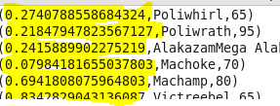

**Question 4:-**



**Explanation:-**

Relation F refers the file that contains Pokemon with their random Numbers. So,we are **ordering the file by Random Numbers ($0)** referred by Relation F **in descending order to get the output.**



Now we are **loading the result of relation G using dump** command.



**OUTPUT:-**

Out of 544 selected pokemons, I have taken screenshot of **first few Pokemons** with their **Random Numbers in descending order.**

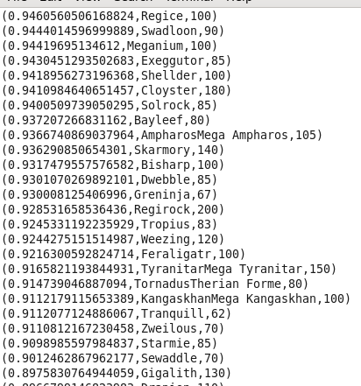

**Question 5:-**



**EXPLANATION:-**

Relation C refers the file that contains Pokemons that are selected in Qualifying Round. So foreach and every row in Relation C, we are generating Random Numbers again using **RANDOM()** function and is referred by relation F..



Relation H refers the file that contains selected Pokemons with their random Numbers. So,we are **ordering the file by Random Numbers ($0)** referred by Relation H **in descending order to get the output.**



Now we are **loading the result of relation I using dump** command.



**OUTPUT:**

In the output, we have ordered the newly generated Random Numbers in Descending order.

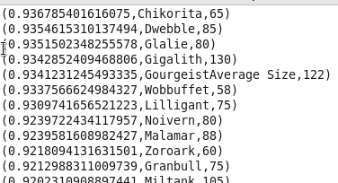

**Question:-**



**EXPLANATION:-**

Relation G refers the file that has pokemons with their random numbers in Descending order. In res_desc1, we have selected top 5 Pokemons from G.



Now we are **loading the result of relation res_desc1 using dump** command.



Relation I refers the file that has pokemons with their random numbers in Descending order. In res_desc2, we have selected top 5 Pokemons from I.



Now we are **loading the result of relation res_desc2 using dump** command.



**OUTPUT OF dump res_desc1:-**

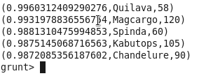

**OUTPUT OF dump res_desc2:-**

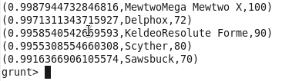

**Question:-**



**EXPLANATION:-**

For each row in res_desc1 and res_desc2, we have generated name (name is $1 in res_desc1 and res_desc2) and HP. They are referred by relation res1 and res2.





Now we are loading the file that is referred by res1 using dump command.



Now we are loading the file that is referred by res2 using dump command.



**OUTPUT OF RES1:-**

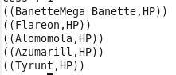

**OUTPUT OF RES2:-**

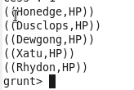

**STORING output of res1 into Disk:-**

We have stored the file referred by res1 into file named Player1.txt under the folder /home/acadgild/pig.



**STORING output of res2 into Disk:-**

We have stored the file referred by res1 into file named Player2.txt under the folder /home/acadgild/pig.

